
everyday heroes
Companion Book of Heroes
“They run in when others run away!”


NEWEARTHCORE MINISTRIES ©2026
www.newearthcore.com

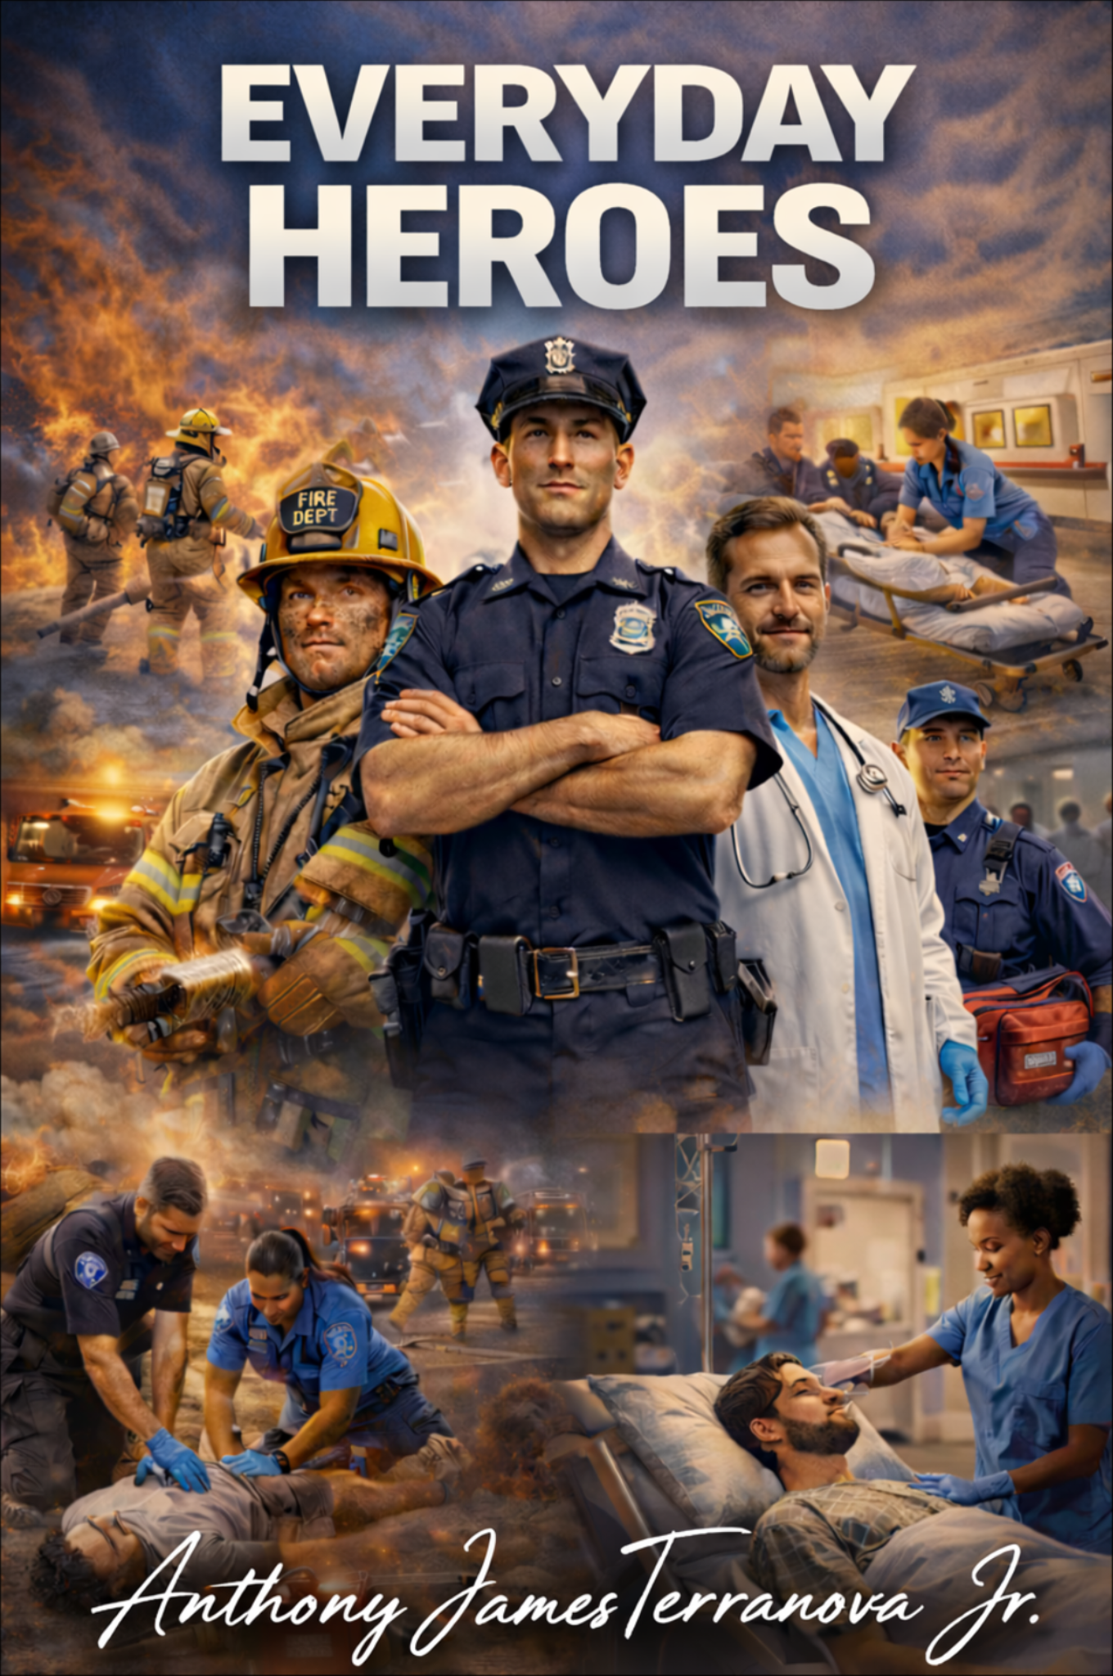
Table of Contents

Opening Essay: What Makes an Everyday Hero?
Chronology at a Glance
Part I — Heroes in History, 1793–1999
1. City of Fever: Absalom Jones, Richard Allen, and the Caregivers of 1793
2. Moses on the Midnight Road: Harriet Tubman and the Courage to Return
3. The Lighthouse Keeper Who Rowed Into Storms: Ida Lewis
4. Five Months in the Ruins: Clara Barton and Johnstown
5. Knocking on Tenement Doors: Lillian Wald and the Visiting Nurses
6. Flames Above Washington Place: The Triangle Fire and the People Who Ran Upward
7. The Year the Nurses Kept Going: The Influenza Pandemic of 1918
8. The Lab That Changed Summer: Jonas Salk and the Fight Against Polio
9. One Child, One Teacher, One Classroom: Barbara Henry and Ruby Bridges
10. Ice Water and Seconds to Spare: The Rescue on the Potomac
Part II — Modern Heroes, 2000–2020
11. The Harbor Becomes a Lifeline: The 9/11 Boatlift
12. A Doctor Who Saw It First: Carlo Urbani and SARS
13. The Hospital Hurricane Teams: Katrina and the Duty to Stay
14. The Man on the Tracks: Wesley Autrey
15. Ninety Minutes in the Dark: Mercy Hospital Joplin
16. Boston Strong in the Trauma Bays: Marathon Medical Teams and Bystanders
17. The Caregivers in the Hot Zone: Ebola Responders
18. Boats in the Streets: Hurricane Harvey and Volunteer Rescuers
19. Frontline and Breakthrough: Nurses and Vaccine Scientists in 2020
Quiz: 20 Multiple-Choice Questions
Answer Key
Selected Bibliography
Public-Domain Photo Acknowledgments
Starter Index

A Long Tradition of Quiet Bravery
Opening Essay: What Makes an Everyday Hero?

“They just suit up and show up every single day.”
An everyday hero usually does not look dramatic before the emergency begins. The hero may be a teacher unlocking a classroom, a nurse tying back her hair for another shift, a ferry captain leaving the dock, a scientist checking results, a construction worker waiting for the train, or a neighbor who happens to own a small boat. What changes everything is not their title, but their decision. When fear arrives, they move toward need instead of away from it.
That is the thread running through the song “Everyday Heroes.” It praises the people who do not serve for applause. They show up because someone must. In American history, those people have worn many different faces. Some were famous later, but many were nearly anonymous at the moment that mattered. A few saved one person. Others saved thousands. Some fought fire or flood. Some healed in epidemics. Some built systems of public care that quietly saved lives for generations.
This companion is built to keep the stories moving. The first half traces a longer history from the early republic to the end of the twentieth century. The second half narrows its focus to 2000–2020, when modern disasters, outbreaks, and mass-casualty events revealed how much society still depends on ordinary courage. The point is not to rank heroes against one another. The point is to notice a pattern: history changes whenever ordinary people decide that another life matters.
A good companion book should do more than inform. It should make the reader look around differently. After reading these stories, the next ambulance siren, emergency-room hallway, school doorway, fire line, lab bench, rescue boat, or public-health briefing should feel connected to a much older and deeper tradition. These are not isolated moments. They are part of a long American habit of quiet bravery.

Stories at a Glance
Chronology at a Glance

Year / Era | Story | Why It Matters
1793 | Yellow fever in Philadelphia | Black caregivers associated with Absalom Jones and Richard Allen step forward to nurse the sick and bury the dead.
1850s | Harriet Tubman’s rescue journeys | Tubman repeatedly returns south to guide enslaved people to freedom.
1854–1881 | Ida Lewis at Lime Rock | The lighthouse keeper earns a reputation for rowing into danger to save lives.
1889 | Johnstown Flood | Clara Barton and Red Cross volunteers turn relief work into a model of organized disaster response.
1890s–1930s | Henry Street Settlement | Lillian Wald and visiting nurses bring care into homes that formal medicine often ignored.
1911 | Triangle Shirtwaist Factory fire | Firefighters, witnesses, and reformers transform a terrible loss into workplace safety change.
1918 | Influenza pandemic | Red Cross nurses and volunteers keep caring for the sick during one of the deadliest health crises in history.
1955 | Polio vaccine declared effective | Jonas Salk and his team help turn a season of fear into a season of hope.
1960 | Ruby Bridges enters William Frantz School | Barbara Henry teaches one child in one classroom while the nation watches.
1982 | Rescue on the Potomac | Civilian and police rescuers brave ice water and rotor wash to save plane-crash survivors.
2001 | 9/11 Boatlift | Civilian mariners and Coast Guard leadership evacuate lower Manhattan by water.
2003 | SARS | Dr. Carlo Urbani recognizes a new disease early and helps trigger a faster response.
2005 | Hurricane Katrina | Hospital teams, emergency physicians, and relief workers continue caring in chaos.
2007 | Wesley Autrey subway rescue | A construction worker uses his own body to shield a stranger from an oncoming train.
2011 | Joplin tornado | Hospital staff evacuate patients through darkness, damage, and confusion.
2013 | Boston Marathon bombing | Bystanders, medics, nurses, and trauma teams turn preparedness into survival.
2014 | Ebola response | Nurses, aides, physicians, and public-health workers face extraordinary risk to stop a deadly outbreak.
2017 | Hurricane Harvey | Volunteer boat owners and official responders rescue stranded residents across flooded neighborhoods.
2020 | COVID-19 frontline care and vaccine research | Healthcare workers endure the first waves while scientists accelerate lifesaving vaccine design.

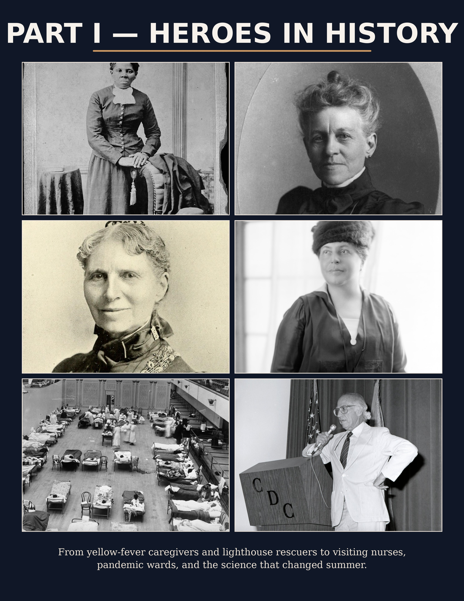

1. City of Fever
1. City of Fever: Absalom Jones, Richard Allen, and the Caregivers of 1793

When yellow fever swept Philadelphia, fear emptied the streets. The city still needed people willing to touch the sick, carry water, lift bodies, and stay when others fled.
In 1793, Philadelphia was the national capital, but it became a place of dread almost overnight. As yellow fever spread, many people with means escaped the city. That left behind the poor, the sick, children, laborers, and the elderly—people who could not simply ride away from danger. It also left behind the need for practical mercy. Someone still had to nurse the fevered, wash linens, carry messages, and bury the dead.
Among those who answered that call were Black Philadelphians associated with Absalom Jones and Richard Allen. They did not enter a grateful city. They entered a frightened one. Later accounts had to defend them against slander and false accusations, which tells us something painful but important: heroism does not always arrive with applause. Sometimes it arrives in a room where people are too afraid even to come close.
What makes this story so powerful is that the work was not theatrical. There were no cameras, no medal ceremonies, and no guarantee that the people doing the helping would even be remembered accurately. Yet the labor was lifesaving all the same. They nursed the sick, coordinated with city leaders, and handled some of the grimmest duties of the epidemic because the city could not function without them.
This is one of the earliest stories in the American record that feels exactly like the spirit of “Everyday Heroes.” The courage was ordinary in appearance and extraordinary in cost. The heroes here were caregivers, organizers, and community members who stepped into danger because people needed them.
Why this story belongs in this book. It reminds readers that some of the first great American stories of heroism were not battlefield stories at all, but stories of nursing, sanitation, burial, and public duty in the middle of disease.

2. Moses on the Midnight Road
2. Moses on the Midnight Road: Harriet Tubman and the Courage to Return

Escaping slavery took courage. Going back for others took a different kind of courage altogether.
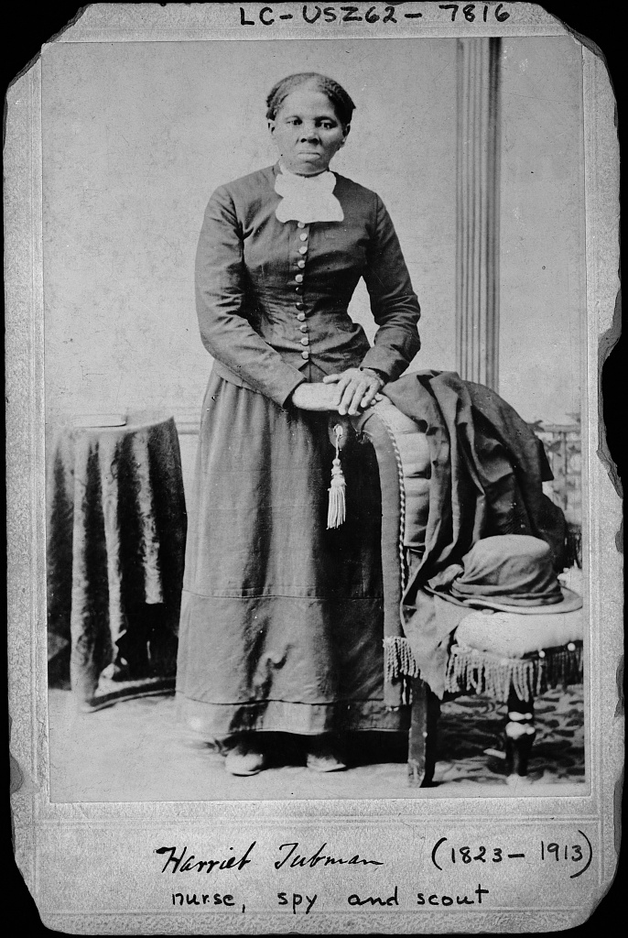
Harriet Tubman, full-length portrait, 1871. Library of Congress via Wikimedia Commons, public domain.
Harriet Tubman is often remembered in broad strokes, but the details matter. She escaped slavery, reached freedom, and then made the kind of decision that separates survival from heroism: she went back. Over and over again, Tubman returned south to guide family members, friends, and others to freedom. She worked in secrecy, traveled by night, trusted memory and signals, and carried the burden of being responsible for other human lives.
That responsibility is what makes Tubman belong in a companion about everyday heroism. She was not commanding an army. She was moving small groups through terror, weather, rumor, and exhaustion. If a baby cried, if a footstep sounded wrong, if a patrol rode too close, every life in the group could be lost. Courage here was not loud. It was steady. It had to keep thinking while afraid.
Tubman’s rescues also show that everyday heroism is not restricted to official roles. She was not waiting for a badge or a title. She saw that people were trapped and decided that being safe herself was not enough. That decision placed her life at risk again and again. It also changed dozens of other lives forever.
Readers know Harriet Tubman as a legend. This chapter invites them to see her as something else too: a practical rescuer. She studied routes, judged risk, timed movement, and refused to let fear have the final word. That is one of the strongest forms of heroism there is.
Why this story belongs in this book. Tubman widens the definition of heroism. Rescue can happen in floodwater, in fire, in a hospital—or on a dark road when one person decides another person must not be left behind.

3. The Lighthouse Keeper Who Rowed Into Storms
3. The Lighthouse Keeper Who Rowed Into Storms: Ida Lewis

Some heroes worked where the whole danger could be seen from shore: a hard sea, a small boat, and not enough time.
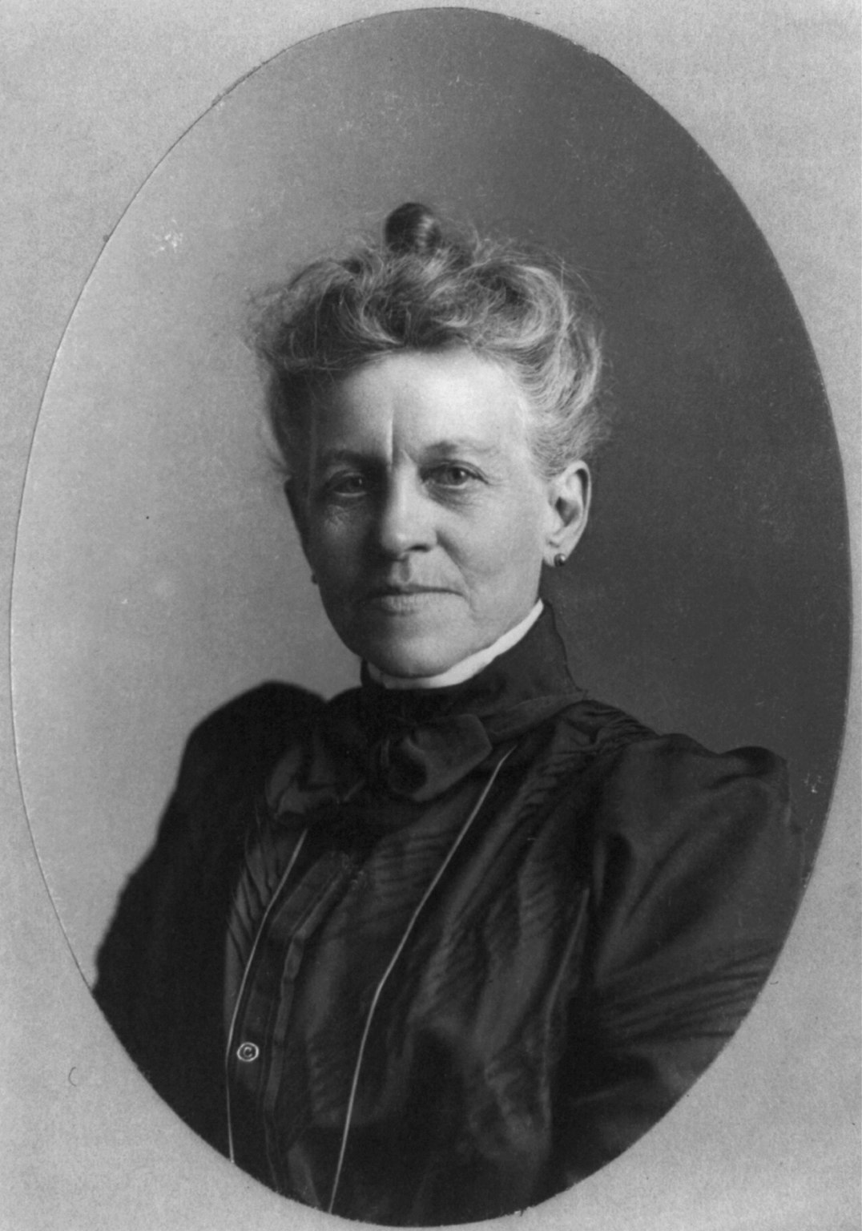
Ida Lewis portrait. Library of Congress via Wikimedia Commons, public domain.
Ida Lewis lived at Lime Rock Light in Rhode Island and became one of the most celebrated life-savers of the nineteenth century. The setting sounds almost too small for greatness: a lighthouse, a rowboat, a rocky harbor. Yet that small setting was exactly what made her heroism feel so human. When boats overturned or people were stranded in the water, she did not stand on shore and hope. She rowed toward them.
What separates Lewis from a one-time rescuer is constancy. She kept doing it. For decades, she served at the lighthouse and built a reputation for practical bravery so strong that newspapers and the public followed her rescues. The U.S. Life-Saving Service and later Coast Guard history preserved her legacy because it was impossible to ignore. She saved dozens of lives and became the first woman to receive the Gold Lifesaving Medal.
There is something deeply moving about the physicality of her work. Lighthouse heroism is not abstract. It is wind, oars, cold water, soaked clothing, and the awful speed with which a person can disappear. Lewis’s rescues were acts of muscle, nerve, and timing, but also of habit. She had trained herself to be the person who responded.
The lesson for this book is clear. Heroism often grows out of repeated readiness. Long before the crisis, the future hero has already become the kind of person who knows how to move, how to stay calm, and how to act.
Why this story belongs in this book. Ida Lewis embodies the line between ordinary service and extraordinary rescue. She was a keeper, a daughter, a rower, and a life-saver—all at once.

4. Five Months in the Ruins
4. Five Months in the Ruins: Clara Barton and Johnstown

Disaster relief is its own kind of heroism: less one grand gesture than a thousand tasks done correctly while people are hurting.
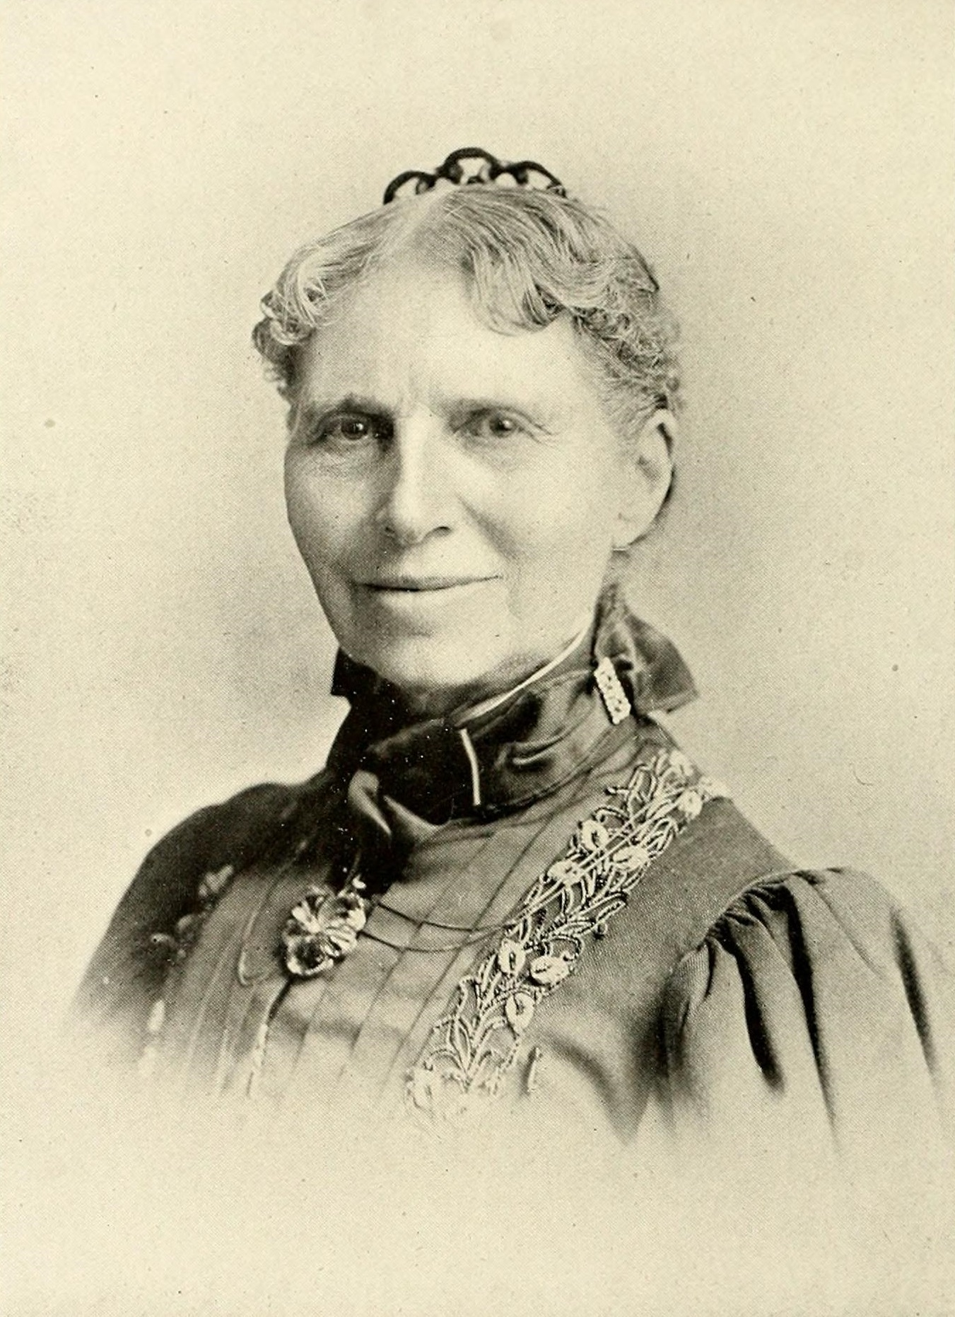
Clara Barton portrait. Public domain via Wikimedia Commons.
The Johnstown Flood of 1889 was one of the great disasters in American history. Water and debris tore through the town, leaving wreckage, grief, and immediate practical needs: shelter, food, medical care, clothing, sanitation, coordination, and hope. Clara Barton and the American Red Cross stepped into that devastation and stayed.
The length of the stay matters. Barton did not simply arrive, survey the damage, and move on. She and the Red Cross remained for months, helping create a model of organized American disaster relief. This is one reason she belongs in a companion to a song about people who “suit up and show up every single day.” The heroism was not only the first response. It was endurance.
Johnstown also reveals a truth that modern readers know from hurricanes, tornadoes, fires, and hospital surges: after the headline moment passes, the real work is still underway. People need to be counted, housed, fed, treated, comforted, and guided. Barton’s form of courage was administrative and compassionate at the same time. She helped turn empathy into structure.
This chapter should feel almost cinematic in a quiet way—mud, timbers, names being checked, food lines forming, supplies arriving, and people who have lost everything trying to understand what tomorrow will be. In that landscape, everyday heroes are the ones who keep building the next hour.
Why this story belongs in this book. Clara Barton’s work at Johnstown helps readers see disaster response as disciplined mercy: organized, practical, and stubbornly humane.

5. Knocking on Tenement Doors
5. Knocking on Tenement Doors: Lillian Wald and the Visiting Nurses

Some heroism is dramatic. Some enters quietly through a front door carrying a medical bag.
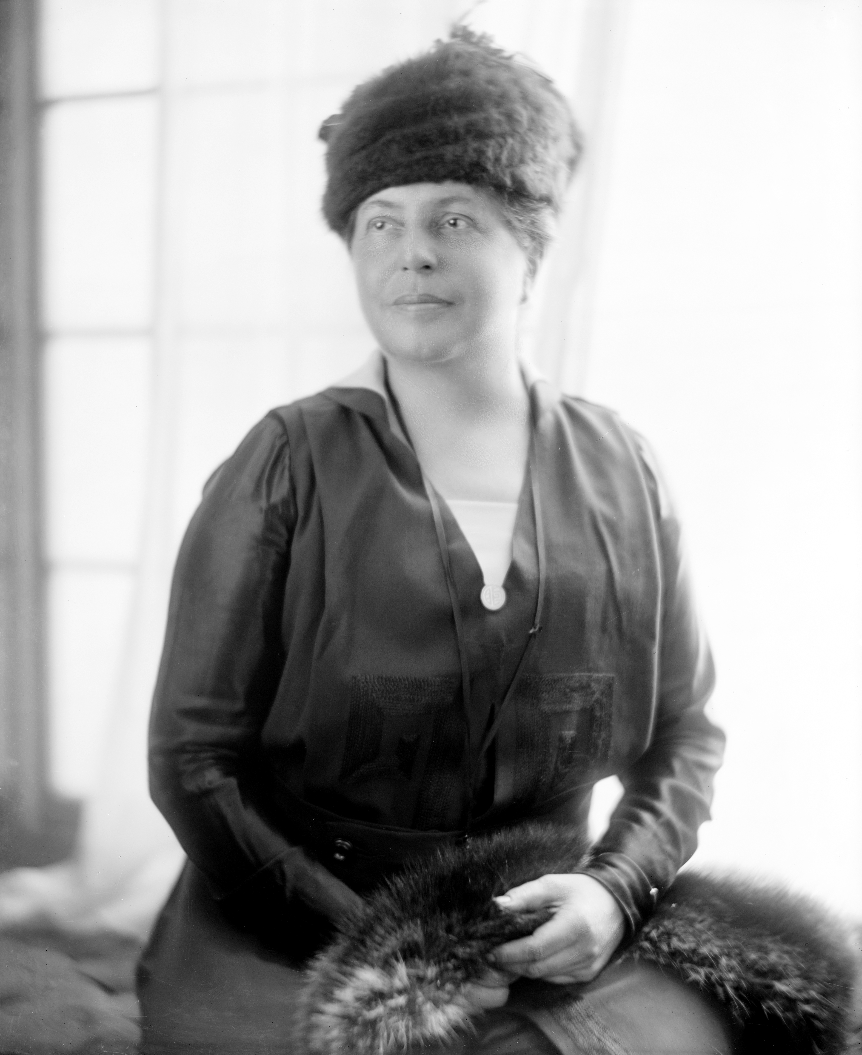
Lillian D. Wald photograph. Library of Congress via Wikimedia Commons, public domain.
Lillian Wald changed the way America imagined care. Through the Henry Street Settlement in New York, she helped build the visiting nurse movement—bringing healthcare directly into homes that hospitals and private medicine often failed to reach. Instead of waiting for desperate people to come to the system, Wald and her nurses carried the system to the people.
This matters because much of everyday heroism is preventive. The hero is not always the person who arrives after catastrophe. Sometimes the hero is the person who prevents a crisis from becoming worse. In crowded tenements, that meant treating illness, teaching hygiene, helping mothers, checking on children, and making health feel possible in places where poverty had made it seem far away.
The numbers tell part of the story. By the time Wald retired, the settlement had employed hundreds of nurses and served more than one hundred thousand patients. But numbers alone miss the emotional truth. Every door opened onto a family. Every visit required trust. The nurses were stepping into crowded kitchens, sickrooms, and narrow hallways where public health was not an abstract term but a daily struggle.
Wald’s legacy belongs here because it turns the very phrase “everyday hero” into a profession of daily compassion. The nurses were not waiting for a famous emergency. They were meeting human need where it lived.
Why this story belongs in this book. This chapter adds a public-health dimension to the book: a hero can save a life in one dramatic moment, but a hero can also save lives by building access, care, and dignity over years.

6. Flames Above Washington Place
6. Flames Above Washington Place: The Triangle Fire and the People Who Ran Upward

When the Triangle Shirtwaist Factory caught fire in 1911, some people fled the building. Others ran toward it.
The Triangle Shirtwaist Factory fire in New York City remains one of the most painful industrial tragedies in American memory. One hundred forty-six workers died. Many were young immigrant women. The images still break the heart: smoke, locked exits, desperate crowds, fire ladders that could not reach high enough, and life nets that could not do what people hoped they could do.
This chapter should not flatten the story into pure tragedy. It should also highlight response: firefighters who tried under impossible conditions, witnesses who carried the truth of what they saw, and reformers who refused to let the dead be forgotten. In that sense, the heroism here includes both the immediate response and the moral response that followed.
One reason the Triangle story belongs in this companion is that it connects rescue to justice. Sometimes heroism means trying to save people in the moment. Sometimes it means changing the system afterward so fewer people need saving. The public outrage after Triangle helped energize workplace safety reforms that changed labor conditions for generations.
The emotional center of the story is simple. Those workers should have come home. The people who ran up stairwells, shouted from below, and fought afterward for safer conditions were answering the same human question that runs through this whole book: what do we owe one another when life is on the line?
Why this story belongs in this book. Triangle turns grief into civic responsibility. It shows that rescue, witness, and reform can all be forms of heroism.

7. The Year the Nurses Kept Going
7. The Year the Nurses Kept Going: The Influenza Pandemic of 1918

Pandemics do not offer clean battle lines. They offer exhaustion, uncertainty, and the need to keep caring anyway.
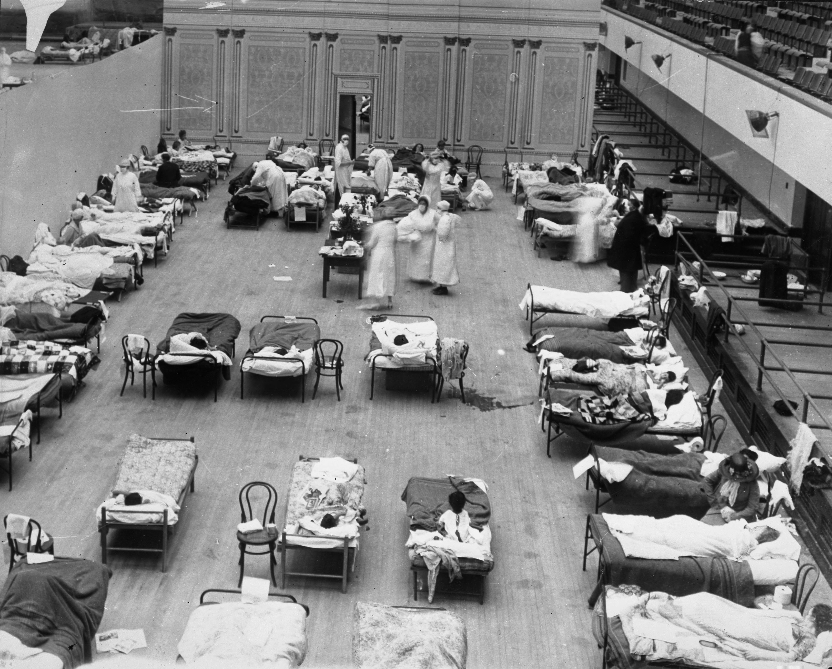
Volunteer nurses tending influenza sufferers in Oakland Municipal Auditorium, 1918. Oakland Public Library via Wikimedia Commons, public domain.
The influenza pandemic of 1918 overwhelmed communities across the United States and around the world. Homes became sickrooms. Hospitals overflowed. Public gatherings were canceled. Fear and rumor traveled almost as fast as the disease itself. In that atmosphere, everyday heroism often looked like a nurse on another long shift or a volunteer carrying food to a quarantined household.
The American Red Cross recruited more than fifteen thousand women, including nurses and people trained in home nursing, to help care for flu victims in the United States. That figure matters not only as a statistic, but as a picture: thousands of ordinary Americans deciding that someone else’s fever, someone else’s child, someone else’s breath mattered enough to step in.
Unlike a single dramatic rescue, pandemic heroism is repetitive. It repeats medicine, meals, cleaning, transport, comfort, and vigil. It is heroic precisely because it must continue after the adrenaline fades. The work is hard, unglamorous, and often lonely.
Readers coming to this chapter after the COVID years will feel the bridge immediately. Masks, strain, staffing, fear of infection, public anxiety—these are not wholly modern experiences. The nurses of 1918 belong in this book because they stood inside that pressure and kept the chain of care from breaking.
Why this story belongs in this book. This chapter gives the book one of its deepest echoes. A song about everyday heroes should remember the caregivers who carried communities through disease, one patient at a time.

8. The Lab That Changed Summer
8. The Lab That Changed Summer: Jonas Salk and the Fight Against Polio

Some heroes meet the crisis at the bedside. Others meet it at the microscope, the notebook, and the trial site.
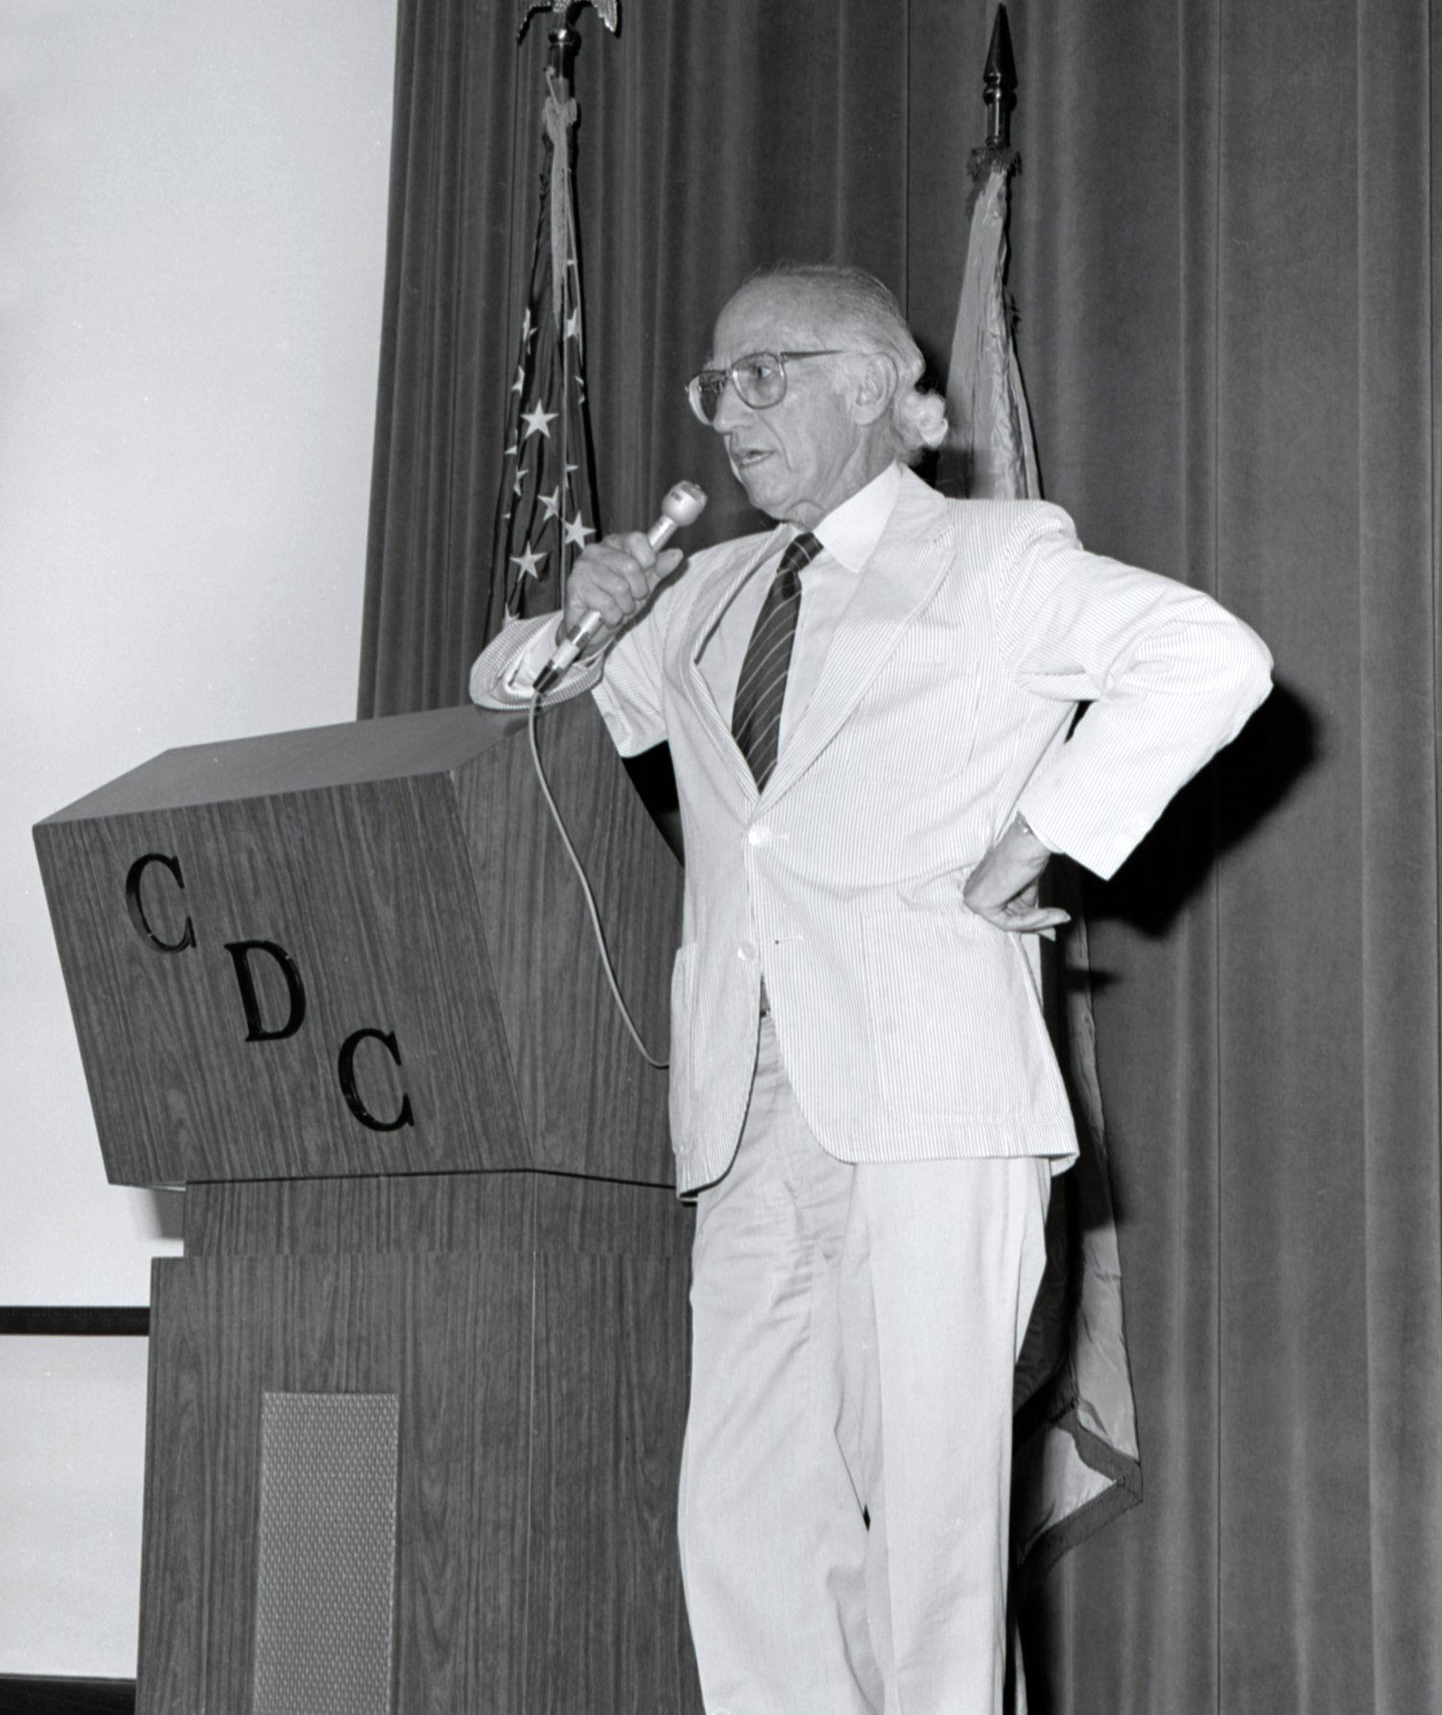
Dr. Jonas Salk during a 1988 CDC visit. CDC Public Health Image Library, public domain.
For generations of American parents, polio was a season of fear. Summer, which should have meant play and freedom, became a season of dread. Parents avoided crowds. Children were warned away from pools and gatherings. The disease could strike quickly and leave paralysis behind. In 1952 alone, the United States recorded more than twenty-one thousand paralytic cases.
The story of Jonas Salk and his team matters because science can be an act of public courage. Laboratory work is not less heroic because it is careful. In fact, carefulness is exactly what makes it heroic. Vaccines require patience, method, testing, collaboration, and a willingness to stay with a problem until hope becomes evidence.
When the first effective vaccine was announced in 1955 as “safe, effective, and potent,” it changed more than medical policy. It changed the emotional weather of American life. It gave parents a reason to exhale. It offered proof that intelligence, persistence, and public trust could turn terror into prevention.
This chapter broadens the book’s vision. Everyday heroism includes doctors, nurses, EMTs, firefighters, and police officers, but it also includes the scientific work that prevents future sirens from sounding quite so often.
Why this story belongs in this book. Science belongs in this companion because saving lives is not only rescue after danger arrives; it is also the disciplined work of preventing danger before it can ruin more families.

9. One Child, One Teacher, One Classroom
9. One Child, One Teacher, One Classroom: Barbara Henry and Ruby Bridges

Sometimes a heroism of care takes place in a room with chalk, a desk, and one student who should not have had to be so brave alone.
When six-year-old Ruby Bridges entered William Frantz Public School in New Orleans in 1960, she walked through hatred toward an education she had every right to receive. Crowds jeered. White parents withdrew their children. The nation remembers Ruby—and rightly so. But this book also has room for Barbara Henry, the Boston teacher who taught Ruby when others refused.
The image is quietly astonishing: an entire school structure collapsing morally around one little girl, and one teacher deciding that the child in front of her still deserves a full year of school. Ruby completed first grade alone with Henry’s support. That sounds simple until one pauses long enough to imagine the emotional weight of it.
Teaching is often described as a profession of long influence, but in this story teaching was also an act of immediate courage. Henry was not rescuing someone from firewater or wreckage. She was rescuing normalcy, dignity, and continuity under hostile pressure. She was saying, in effect, that fear does not get to decide whether a child learns to read.
This chapter helps the companion book honor a form of heroism that is deeply American and deeply local. The classroom can be a rescue site too—especially when one adult refuses to let intimidation define a child’s future.
Why this story belongs in this book. Barbara Henry belongs in this book because everyday heroes often protect not only lives, but also the conditions that make a decent life possible: safety, dignity, and education.

10. Ice Water and Seconds to Spare
10. Ice Water and Seconds to Spare: The Rescue on the Potomac

A plane crashes into ice-clogged water. Survivors cling to wreckage. Bystanders watch a woman losing strength. Then ordinary people decide to move.
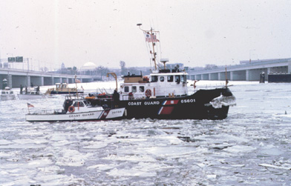
U.S. Coast Guard Cutter Capstan at the Air Florida crash site, Potomac River, January 1982. U.S. federal government image, public domain.
The 1982 crash of Air Florida Flight 90 into the Potomac River produced one of the clearest modern pictures of split-second everyday heroism. Rescue was not the work of one person alone. It came from a chain: police helicopter crew members navigating dangerous conditions, a sheet-metal worker entering the freezing river, and Lenny Skutnik plunging in when he could not bear to watch one more victim slip away.
That chain matters. Heroism often arrives cooperatively. The public tends to remember the single dramatic figure, but real rescue depends on many hands, many judgments, and many risks taken in sequence. In this case, rotor wash, ice, wreckage, numb limbs, and cold water turned every second into a test.
What makes the Potomac rescue belong in this book is its raw recognizability. No one there had time to form a committee or write a plan. They saw a human life fading and acted. Skutnik later resisted the label “hero,” which somehow makes the story feel even more fitting here. Many everyday heroes do not experience their actions as greatness. They experience them as necessity.
This chapter provides an emotional bridge to the modern half of the book. It is media-age heroism, caught on camera, but still rooted in the oldest truth: someone was in mortal danger, and strangers chose not to stand still.
Why this story belongs in this book. The Potomac rescue gives the book one of its clearest portraits of spontaneous civilian courage working alongside trained responders.

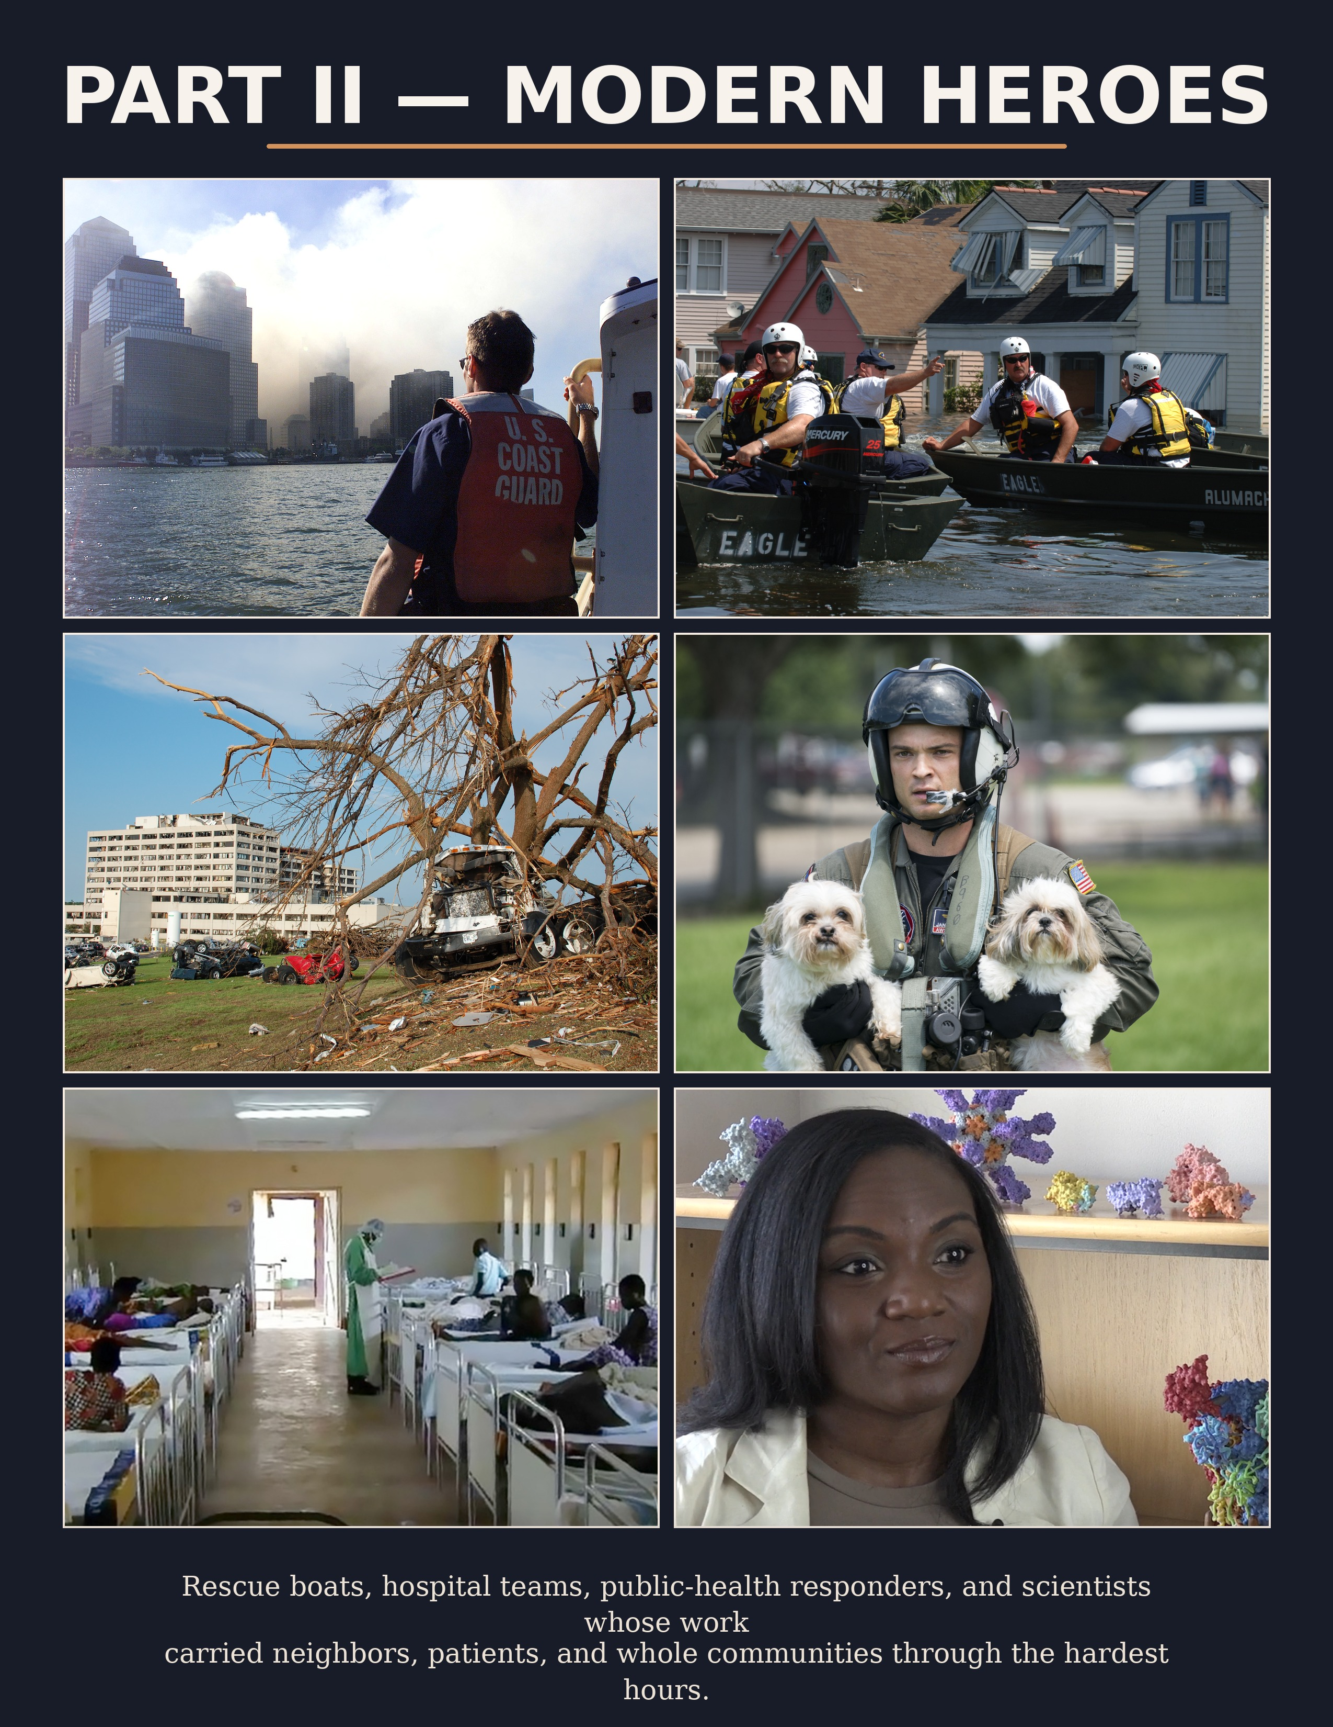

11. The Harbor Becomes a Lifeline
11. The Harbor Becomes a Lifeline: The 9/11 Boatlift

When bridges and tunnels closed after the attacks of September 11, lower Manhattan became an island of smoke and shock. Rescue came by water.
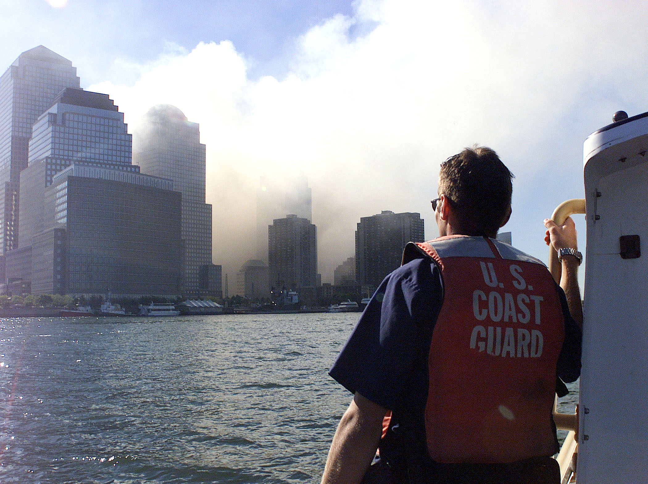
Coast Guard crewmember in New York Harbor after the World Trade Center attack. U.S. Coast Guard Historian’s Office, public domain.
The images of 9/11 often focus upward—towers, ash, flame, collapse. But one of the great rescue stories of that day happened at the edge of the island, where ferries, tugboats, private vessels, and other mariners turned the harbor into a lifeline. Under Coast Guard direction and with civilian initiative, hundreds of boats helped evacuate more than half a million people from Manhattan in less than eight hours.
The scale is almost difficult to imagine. This was not a neat, pre-scripted operation. It was a fast-forming, improvised maritime response carried by people who understood boats, currents, loading, and urgency. Ferry crews who had started the morning expecting ordinary commuter runs suddenly became mass-evacuation leaders. Private boat owners saw the need and joined.
This chapter belongs in the companion because it captures the exact spirit of the song’s refrain. The heroes were literally all around the city, hidden in plain sight until the emergency revealed them. Their tools were not capes, but hulls, radios, lines, and local knowledge.
The boatlift also carries a note of grace. On one of the darkest mornings in modern American history, the water became a road out. That image feels almost biblical: smoke behind, small craft ahead, ordinary people making room for strangers and taking them home.
Why this story belongs in this book. The 9/11 boatlift proves that large-scale heroism can be made of ordinary skills. A normal workday can become the day a ferry captain saves thousands of lives in pieces.

12. A Doctor Who Saw It First
12. A Doctor Who Saw It First: Carlo Urbani and SARS

Modern heroism also belongs to the professionals who recognize danger early enough to warn the world.
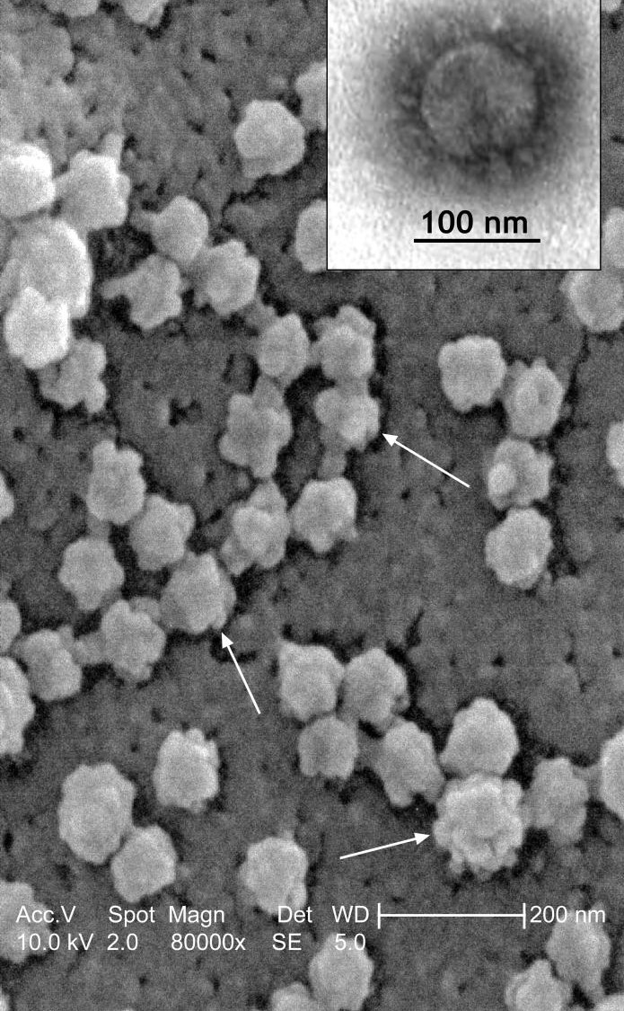
Scanning electron micrograph of SARS coronavirus. CDC, public domain.
In 2003, Dr. Carlo Urbani, a World Health Organization physician working in Vietnam, examined a patient with what looked at first like a severe respiratory illness but was in fact something more alarming. He recognized that the disease was not ordinary influenza and helped sound the early alarm about what became known as SARS.
Why include this story in a companion rooted in everyday heroism? Because recognition is a form of rescue. The doctor who understands a threat before others do can save lives far beyond the walls of one hospital room. Urbani’s action did not look like a sprint into flames, but it demanded the same moral seriousness: attention, courage, and responsibility.
The story carries deep cost. Urbani later died of SARS himself. That fact gives the chapter weight, but the chapter should not be written merely as tragedy. It should be written as witness. He saw clearly. He responded quickly. And his clarity helped shape a broader global response.
Readers may remember later outbreaks more vividly, but SARS marked an important modern lesson: in public health, heroes are often the people who notice the pattern in time.
Why this story belongs in this book. This chapter honors medical vigilance as heroism. To see the threat clearly and act decisively is also a way of saving lives.

13. The Hospital Hurricane Teams
13. The Hospital Hurricane Teams: Katrina and the Duty to Stay

Floodwater changes the meaning of an ordinary hospital corridor. It becomes a place where duty, fear, triage, and exhaustion all meet.
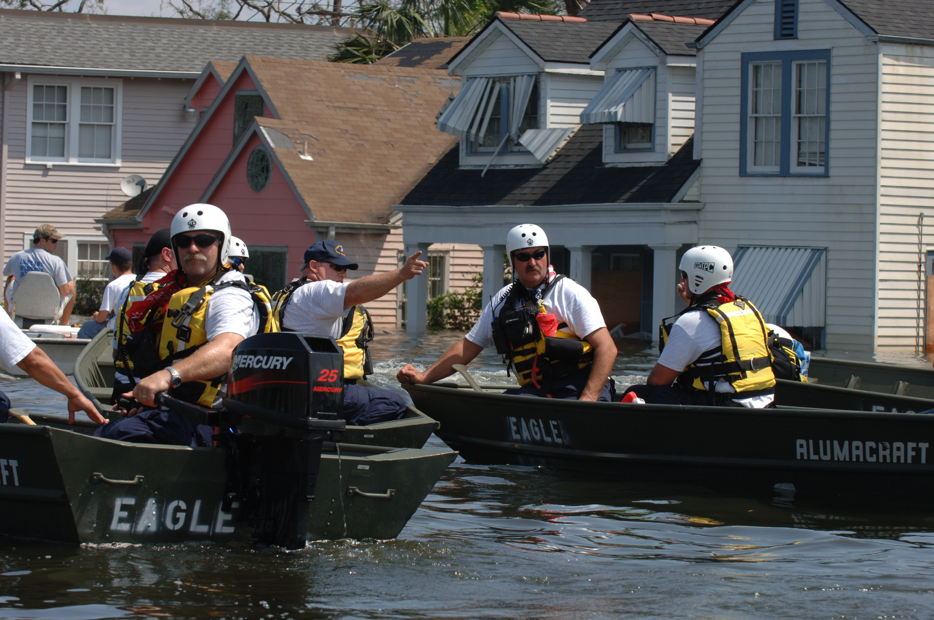
FEMA Urban Search and Rescue Task Force, New Orleans, August 31, 2005. FEMA image, public domain.
Hurricane Katrina left behind countless stories of systemic failure, but also stories of stubborn human duty. Among the strongest were the hospital teams—physicians, nurses, aides, respiratory therapists, and support staff—who stayed with patients inside failing systems. Power, transport, communications, staffing, and supplies all became unstable. Yet caregivers kept making rounds, monitoring, lifting, reassuring, and deciding.
There is no need to romanticize the suffering to tell the truth. Disaster medicine is messy, morally exhausting, and often unfair. But that is exactly why these teams belong in a companion about everyday heroes. They were not operating in ideal conditions. They were operating in the collapse of ideal conditions.
Research written after Katrina noted that large numbers of emergency physicians in the affected region continued treating patients despite major personal and professional risk. That broad fact points toward thousands of smaller human acts: a nurse staying by a ventilated patient, an aide helping move a bed, a doctor refusing to walk away because the people upstairs could not walk away either.
This chapter should be written with reverence but also realism. Courage is sometimes confusion handled with compassion. In Katrina’s hospitals, heroism often looked like staying longer than anyone should have had to stay.
Why this story belongs in this book. The hospital teams after Katrina show that everyday heroism is often fidelity: refusing to abandon the vulnerable when circumstances become unbearable.

14. The Man on the Tracks
14. The Man on the Tracks: Wesley Autrey

One minute he was a father on a subway platform. The next minute he was the difference between life and death.
In 2007, Wesley Autrey, a New York construction worker, was waiting on a subway platform with his daughters when a young man suffered a seizure and fell onto the tracks. With a train approaching, Autrey jumped down, tried to pull the man up, realized there was no time, and pressed him into the trough between the rails while covering him with his own body as the train passed above them.
The story still shocks because of its physical intimacy. This was not a distant rescue. It was metal, noise, dirt, impact, and the knowledge that inches mattered. The platform was full of witnesses, but Autrey was the one who moved. That single detail reveals why everyday hero stories matter. They ask a difficult question: why do some people act when others freeze?
Autrey’s occupation matters too. He was not introduced to the world as a celebrity or a high official. He was a working man on a commute. That is precisely why he fits the song. He looked ordinary until the emergency revealed what kind of ordinary he was.
There is a tenderness in the story as well. He was with his children. They saw what he did. In a single act, Autrey saved a stranger and gave his daughters a living definition of courage.
Why this story belongs in this book. This chapter is almost a perfect lyric match for the song. It is sudden, selfless, physical, and unforgettable.

15. Ninety Minutes in the Dark
15. Ninety Minutes in the Dark: Mercy Hospital Joplin

An EF-5 tornado hits a hospital. Windows blow out. Systems fail. The building is wounded while patients still need care.
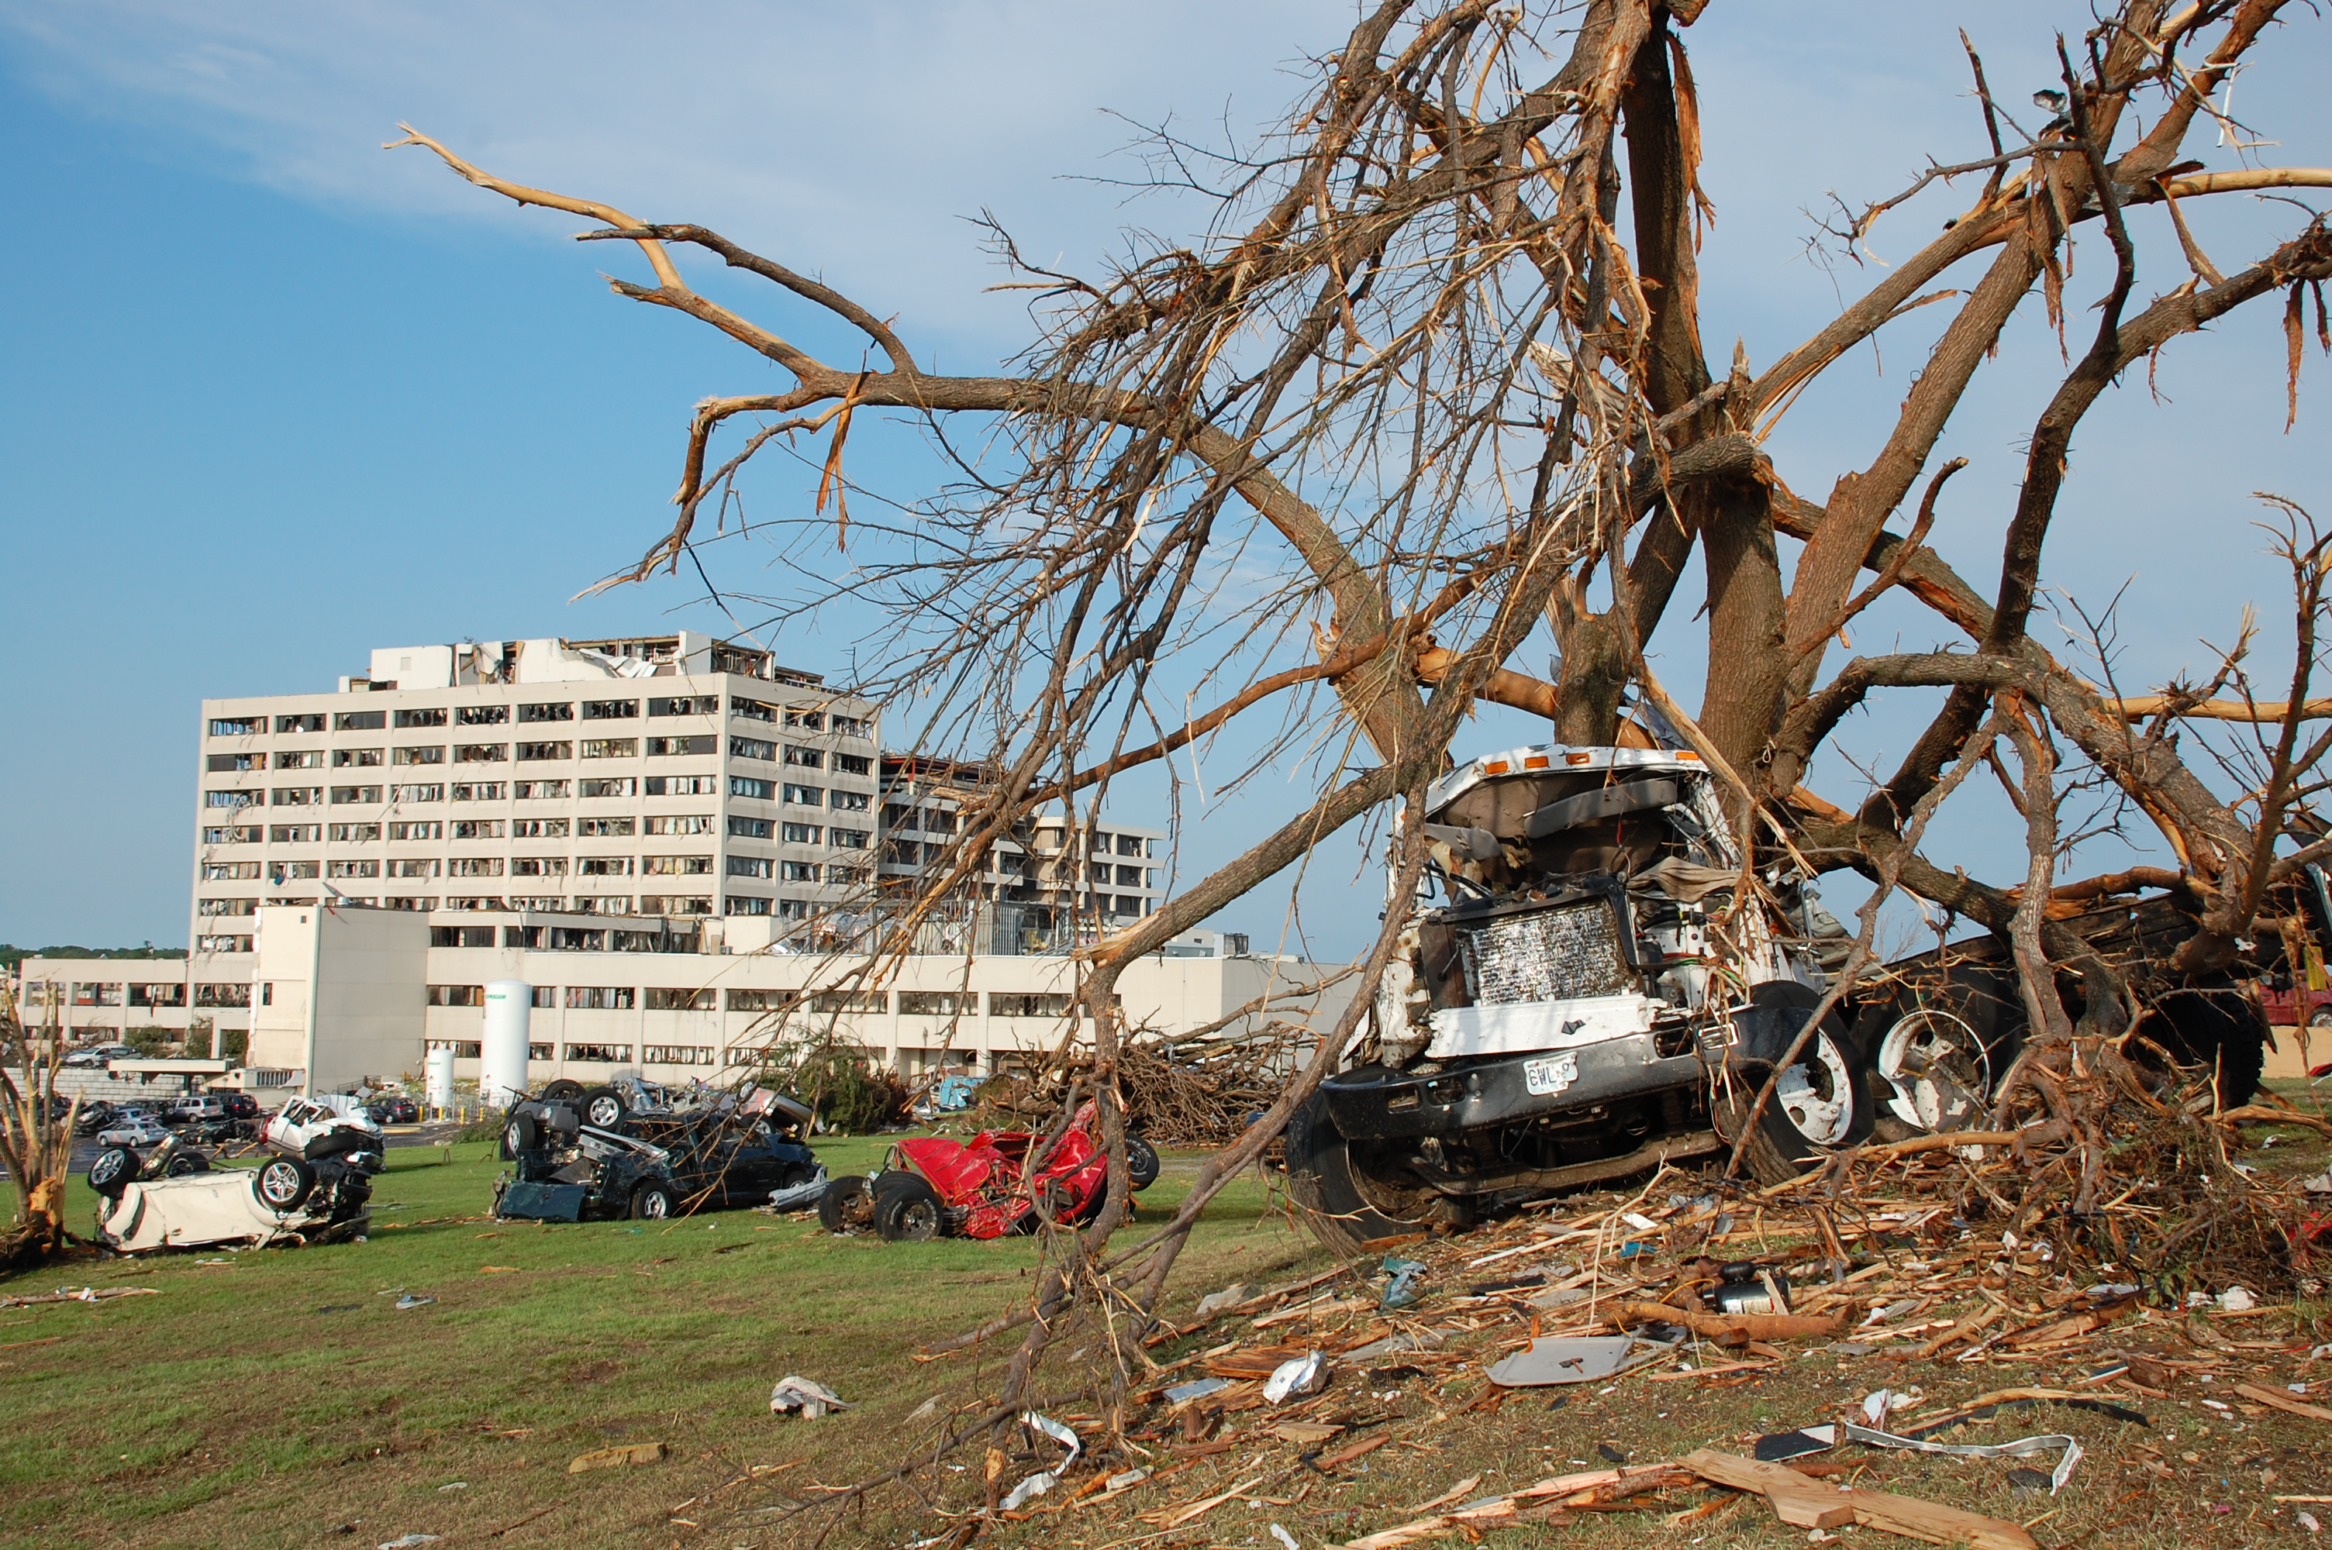
St. John’s Regional Medical Center after the May 2011 Joplin tornado. FEMA image, public domain.
When the 2011 tornado struck Joplin, Missouri, Mercy Hospital Joplin—then St. John’s Regional Medical Center—sustained catastrophic damage. In the chaos that followed, staff evacuated more than 180 patients, including critical-care patients, through dark stairwells and dangerous conditions. The story has the pace of a thriller, but its moral center is simple: caregivers refused to panic away from their duty.
Hospital evacuations are harder than most people imagine. Patients are not identical bodies to be moved quickly from point A to point B. Some are ventilated. Some cannot walk. Some are frightened or disoriented. Some need medications, monitors, or constant support. During Joplin’s evacuation, the building itself had become a hazard, which meant the rescuers had to save lives while escaping danger at the same time.
This chapter should keep its suspense, because the suspense belongs to the truth. Damage, water, fumes, debris, and darkness all mattered. Yet the more meaningful detail is that the staff’s responsibility did not end once the last patient left the damaged building. Care had to continue elsewhere. Heroism did not stop at the exit door.
Joplin belongs in this book because it shows that medical heroism is often logistical, emotional, and physical all at once. The heroes had no choice but to become calm enough for everyone else.
Why this story belongs in this book. Readers will remember the image of nurses and staff carrying life through stairwells when the building itself could no longer protect anyone.

16. Boston Strong in the Trauma Bays
16. Boston Strong in the Trauma Bays: Marathon Medical Teams and Bystanders

On Patriots’ Day in 2013, the finish line became a mass-casualty scene. Survival depended on preparation—and on people who moved without waiting to be told twice.
The Boston Marathon bombing produced a terrifyingly compressed emergency: explosions, smoke, limb injuries, blood loss, confusion, and crowds. Yet the city’s response became an important study in how readiness and courage work together. Bystanders applied pressure. Volunteers and medics reacted immediately. Trauma centers that had planned for disasters translated drills into real care.
Medical literature written after the bombing points to a striking fact: hundreds of patients were treated across dozens of hospitals, and many of the most severely injured survived. That outcome did not happen by accident. It happened because trained people were ready to do hard things fast, and because ordinary people near the blast did not flee responsibility.
This chapter should honor both kinds of response. The bystander with a belt or an improvised tourniquet matters. So do the nurses opening beds, the surgeons heading to operating rooms, and the staff leaders who made sure chaos did not overtake the hospitals. Heroism here is shared. It begins on the street and continues all the way into recovery rooms.
The power of the Boston story lies in its choreography under pressure. In a matter of minutes, civic courage moved from pavement to ambulance to trauma bay. That is the modern form of the same old truth: someone is hurt, and people show up.
Why this story belongs in this book. This chapter lets the companion book celebrate both lay courage and professional excellence, side by side.

17. The Caregivers in the Hot Zone
17. The Caregivers in the Hot Zone: Ebola Responders

Ebola made the simplest act of care feel dangerous: touch, transport, cleaning, treatment, burial, all under the shadow of infection.
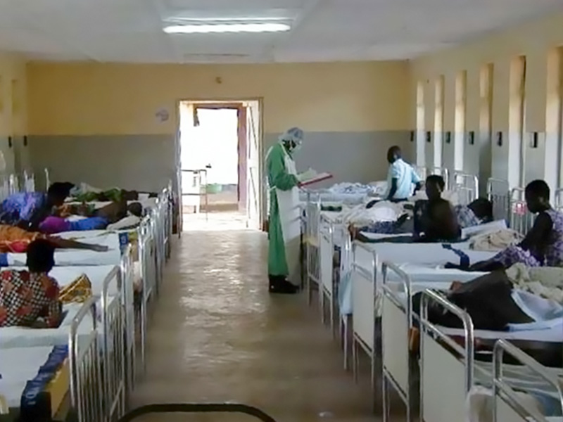
Isolation ward during an Ebola outbreak in Gulu Municipal Hospital, Uganda, 2000. Public domain via Wikimedia Commons.
During the 2014–2016 West Africa Ebola epidemic, healthcare workers faced extraordinary risk. Nurses, nurse aides, physicians, burial teams, lab workers, and public-health responders entered treatment zones where fear was justified and mistakes could be fatal. The story belongs in this companion because it is one of the clearest modern examples of compassion under biological danger.
Official reports documented how often healthcare workers themselves became ill, especially in the early phases of the epidemic, and how urgent it became to improve infection control, training, protective equipment, and safe-care systems. Yet behind those systems were human beings. Someone had to put on the gear, walk in, and care for a patient who might die far from family.
There is a powerful moral beauty in that decision. Ebola patients were often isolated not because they were unloved, but because the disease made closeness perilous. Caregivers became the human bridge between sickness and abandonment. They carried medicine, water, explanation, and presence into places where terror could easily have emptied the room.
This chapter should be written with solemn admiration. Not flashy admiration, but the kind reserved for people who continue to do the needed thing even when the needed thing is frightening.
Why this story belongs in this book. Ebola responders remind readers that heroism can wear gloves, face shields, and protective suits—and still be tender at heart.

18. Boats in the Streets
18. Boats in the Streets: Hurricane Harvey and Volunteer Rescuers

When Houston flooded in 2017, roads disappeared. In many neighborhoods, rescue had to float.
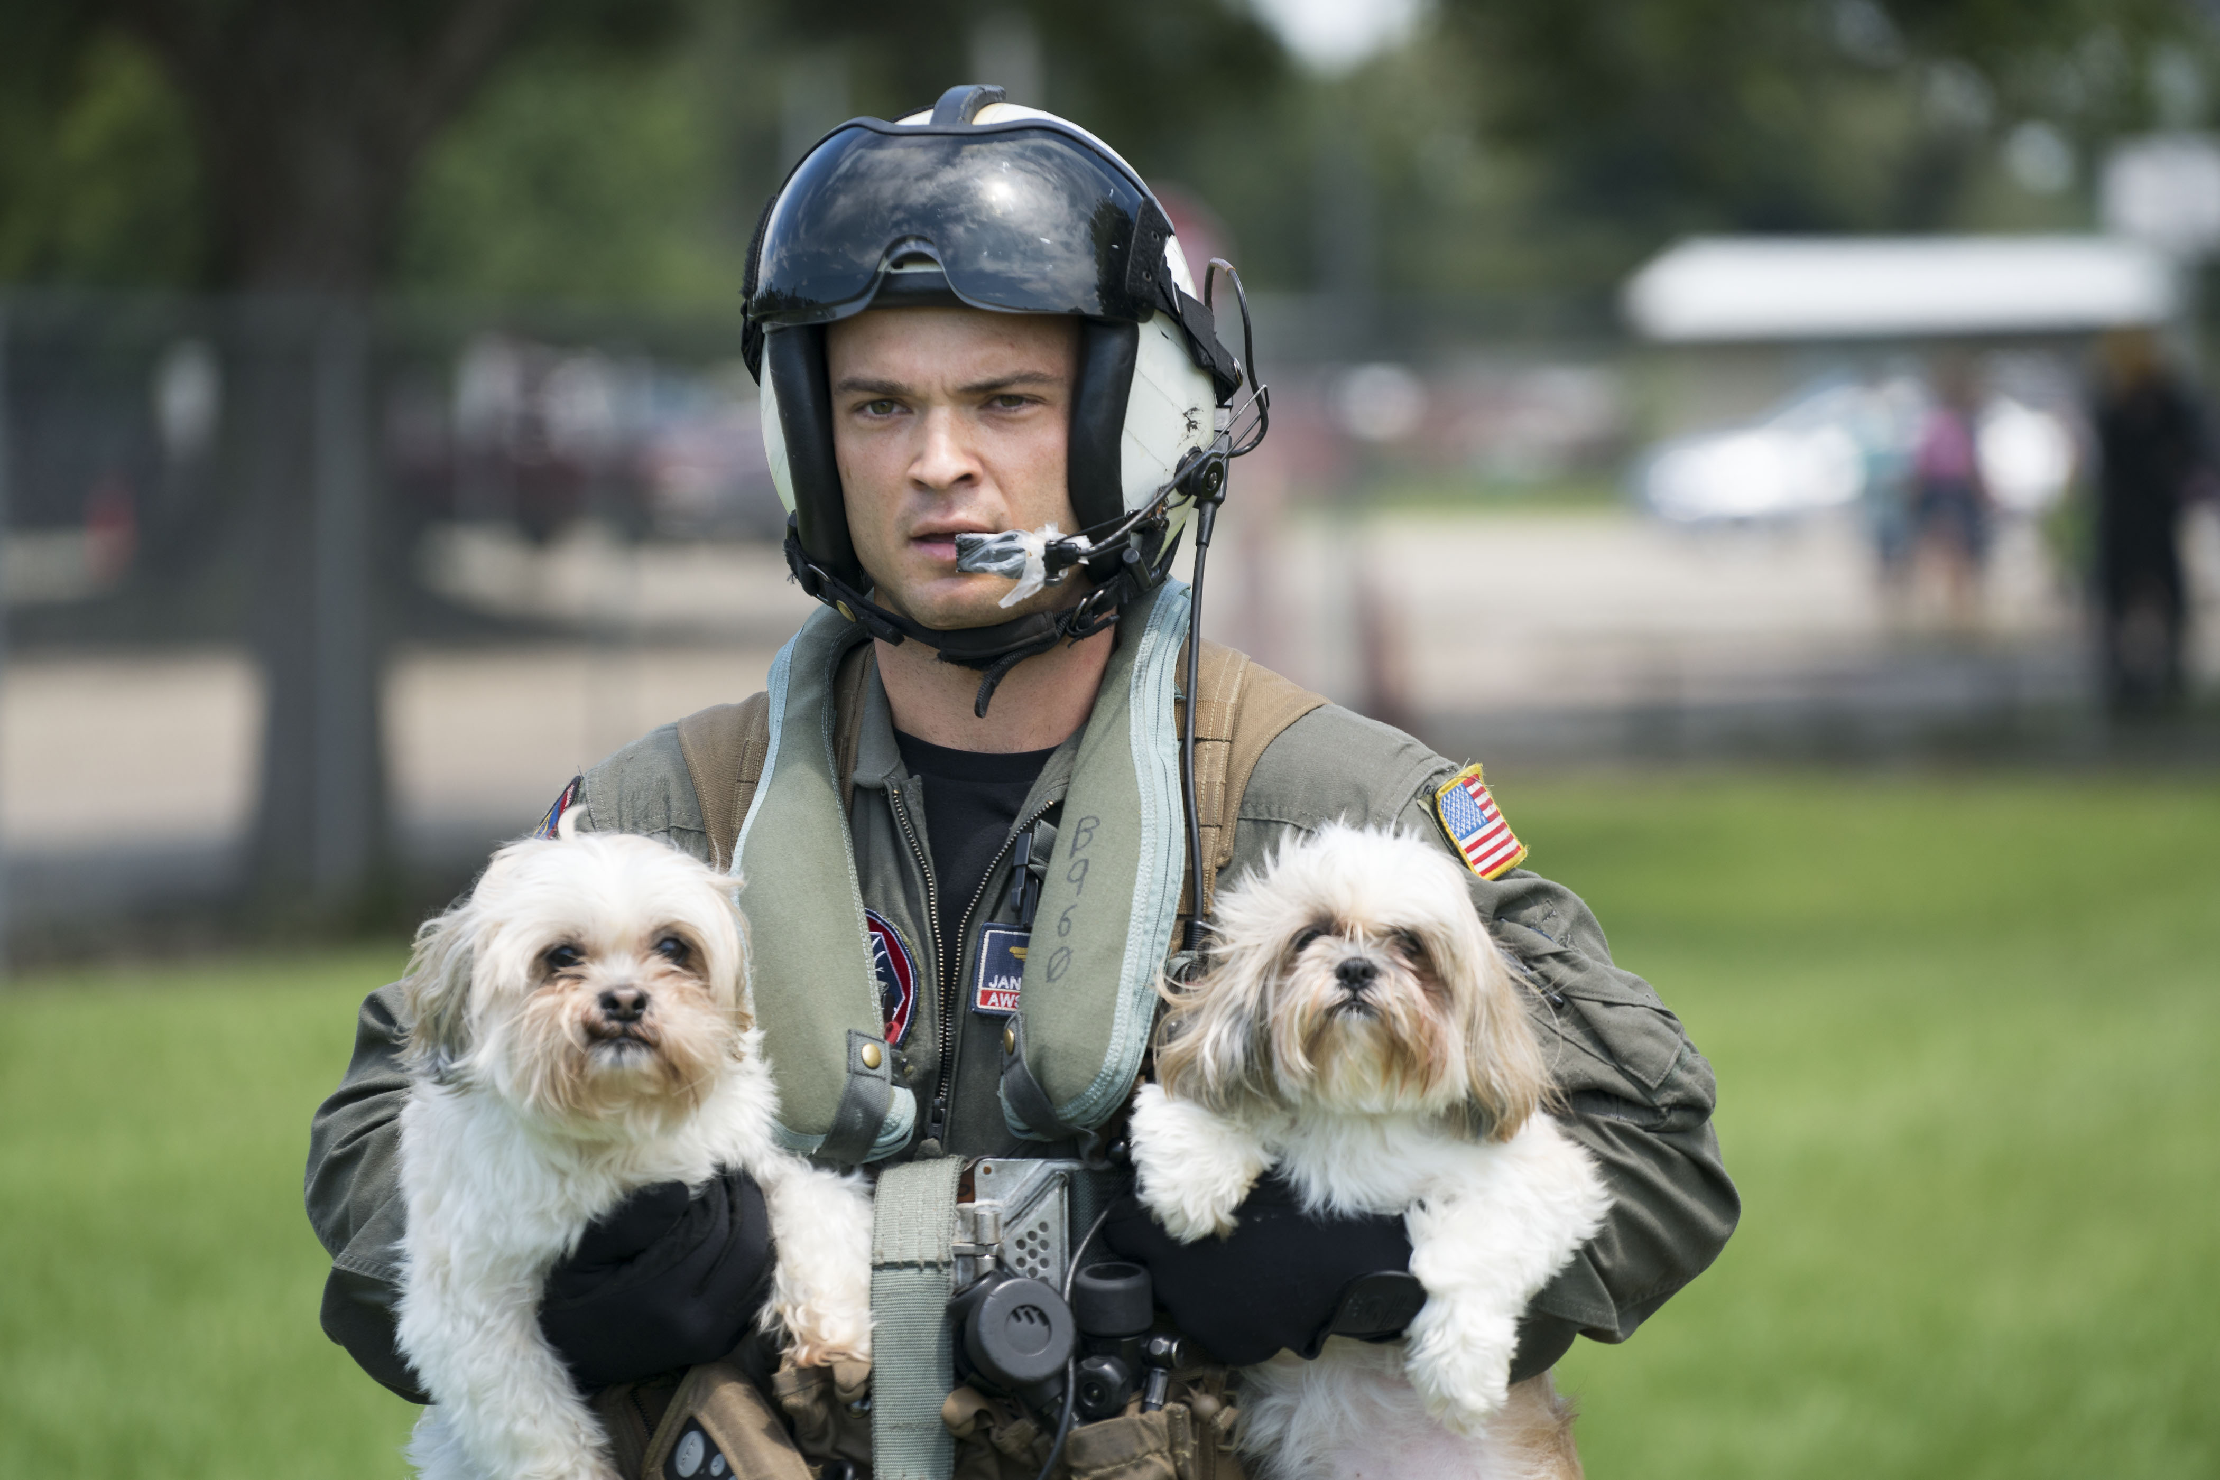
Rescue mission during Hurricane Harvey relief efforts. U.S. Navy image, public domain.
Hurricane Harvey created a disaster landscape in which ordinary neighborhoods became temporary waterways. In that setting, volunteer boat owners—often grouped under the broad popular label of the Cajun Navy or related volunteer efforts—joined official responders to rescue stranded residents, deliver medications, and reach people trapped by rising water.
One reason this story belongs in the companion is that it feels so recognizably American in the best way. People looked at their trucks, trailers, jon boats, airboats, fishing boats, and local knowledge and realized those ordinary possessions had suddenly become rescue equipment. A weekend skill became a lifesaving skill.
The Harvey response also shows how modern heroism is hybrid. Formal emergency systems matter enormously, but so do spontaneous civic networks. In some places, the difference between danger and rescue was simply whether a volunteer knew the neighborhood and had a boat that could fit down the street that was no longer a street.
This chapter should move quickly and visually: porches becoming loading points, medicines being ferried to facilities, anxious pets lifted aboard, neighbors checking on elders, and strangers waving rescuers toward one more house.
Why this story belongs in this book. Harvey reinforces one of the biggest themes of the book: everyday heroism often begins with whatever a person already has in hand and a willingness to use it for somebody else.

19. Frontline and Breakthrough
19. Frontline and Breakthrough: Nurses and Vaccine Scientists in 2020

The year 2020 asked two heroic things at once: for caregivers to endure the first waves, and for scientists to move faster than fear.
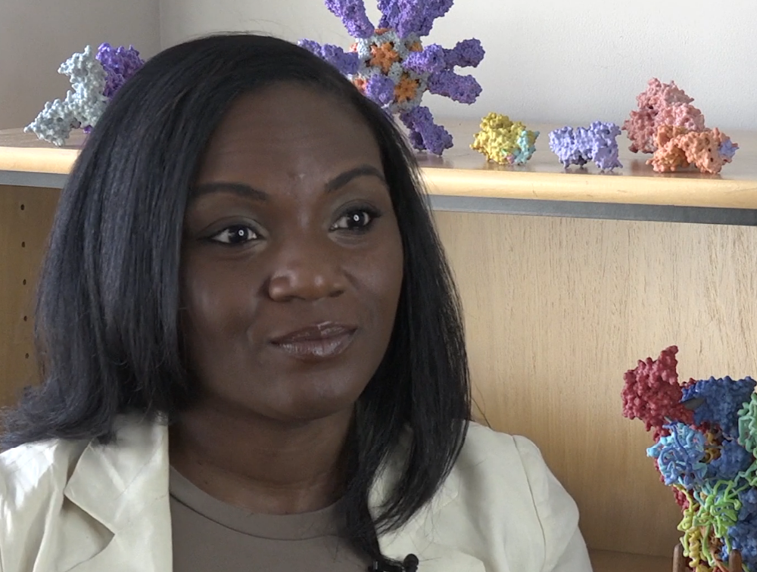
Dr. Kizzmekia Corbett of NIAID’s Vaccine Research Center, January 2020. NIH image, public domain.
The opening year of the COVID-19 pandemic made the word hero feel inadequate and unavoidable at the same time. Nurses, physicians, aides, respiratory therapists, emergency staff, housekeeping teams, transport staff, and countless others worked through uncertainty, exposure, fatigue, grief, and rapidly shifting procedures. In personal accounts, frontline nurses often described fear of contagion alongside a fierce bond with coworkers—almost a family formed under pressure.
At the same time, another form of heroism unfolded in research settings. At the NIH Vaccine Research Center and allied laboratories, scientists including Barney Graham and Kizzmekia Corbett helped drive the design work that supported rapid vaccine development. Their contribution belongs in this book because it demonstrates that lifesaving courage can operate at the pace of science as well as the pace of emergency response.
These are not competing stories. They are one story with two fronts. In hospitals, people fought to keep patients alive. In laboratories, people fought to shorten the future suffering of millions. Both required endurance. Both required discipline. Both were grounded in service rather than spectacle.
This chapter should close the main narrative arc of the book because it brings the whole companion together. The song thanks the people who show up. In 2020, they showed up in hallways, ICUs, ambulance bays, testing sites, and research centers. Some saved the life in front of them. Some helped save lives they would never meet.
Why this story belongs in this book. This final chapter widens gratitude. The everyday hero in modern society may carry a stethoscope, push a medication cart, clean an isolation room, analyze a spike protein, or work through one more impossible shift.

Quiz: 20 Multiple-Choice Questions

1. Which 1793 epidemic drew Black caregivers associated with Absalom Jones and Richard Allen into lifesaving service?
A. Cholera
B. Yellow fever
C. Smallpox
D. Measles
2. What made Harriet Tubman’s courage especially extraordinary after she escaped slavery?
A. She became a governor
B. She returned repeatedly to rescue others
C. She invented a medical treatment
D. She led a city fire department
3. Ida Lewis is best remembered for saving lives as a:
A. Railroad engineer
B. School principal
C. Lighthouse keeper
D. Newspaper editor
4. Clara Barton and Red Cross volunteers became a model of organized disaster relief after the:
A. Great Chicago Fire
B. Johnstown Flood
C. San Francisco Earthquake
D. Dust Bowl
5. Lillian Wald’s major contribution was helping build the movement of:
A. Volunteer firefighters
B. Visiting nurses
C. Harbor pilots
D. Air-traffic controllers
6. How many workers died in the Triangle Shirtwaist Factory fire?
A. 46
B. 92
C. 146
D. 246
7. During the 1918 influenza pandemic, the American Red Cross recruited more than how many women to help care for flu victims in the United States?
A. 1,500
B. 5,000
C. 10,000
D. 15,000
8. The announcement in 1955 that a vaccine was “safe, effective, and potent” referred to the fight against:
A. Tuberculosis
B. Polio
C. Malaria
D. Rabies
9. Who taught Ruby Bridges when she completed first grade alone in an integrated school?
A. Clara Barton
B. Barbara Henry
C. Lillian Wald
D. Ida Lewis
10. The 1982 Rescue on the Potomac involved rescuers entering or hovering over:
A. A mine shaft
B. A burning school
C. Ice-clogged river water
D. A collapsed tunnel
11. The 9/11 Boatlift evacuated people from lower Manhattan primarily by:
A. Subway
B. Helicopter
C. Bus convoy
D. Boat
12. Dr. Carlo Urbani is remembered for helping identify and raise the alarm about:
A. SARS
B. Polio
C. Ebola
D. Influenza A
13. In the Katrina chapter, the main heroic theme is the duty of hospital teams to:
A. Cancel treatment
B. Stay with vulnerable patients
C. Avoid flood zones
D. Close all clinics permanently
14. Wesley Autrey saved a stranger by jumping onto:
A. An airport runway
B. A highway median
C. Subway tracks
D. A ferry ramp
15. After the Joplin tornado struck Mercy Hospital, staff evacuated approximately how many patients?
A. 83
B. 123
C. 183
D. 283
16. A key lesson from the Boston Marathon response is that preparedness and rapid action by bystanders and trauma teams can:
A. Slow survival
B. Improve survival
C. Replace hospitals
D. Eliminate all injuries
17. Why do Ebola responders appear in this companion?
A. They served in a sports league
B. They designed bridges
C. They cared for highly infectious patients under extreme risk
D. They only worked remotely
18. During Hurricane Harvey, many rescues depended on:
A. Horseback patrols
B. Volunteer boat owners working alongside official responders
C. Passenger trains
D. Underground shelters
19. The 2020 chapter pairs frontline nurses with vaccine scientists to show that heroism can happen in:
A. Only laboratories
B. Only emergency rooms
C. Both care settings and research settings
D. Only government offices
20. Which statement best matches the theme of this companion?
A. Heroes are always famous before the crisis begins
B. Everyday heroism often appears in ordinary people doing the needed thing
C. History is made only by generals
D. Rescue and care have little to do with one another

Answer Key

1. B, 2. B, 3. C, 4. B, 5. B, 6. C, 7. D, 8. B, 9. B, 10. C, 11. D, 12. A, 13. B, 14. C, 15. C, 16. B, 17. C, 18. B, 19. C, 20. B

Selected Bibliography

A practical working bibliography anchored in primary sources, official histories, government archives, and institutional records.
• American Red Cross. “A Look Back at the Great Flood of 1889.”
• American Red Cross. “Red Cross Nursing.”
• American Red Cross. “Significant Dates in History.”
• Centers for Disease Control and Prevention. “50th Anniversary of the First Effective Polio Vaccine.”
• Centers for Disease Control and Prevention. “Polio and The Epidemic Intelligence Service (EIS).”
• Centers for Disease Control and Prevention. “Chapter 18: Poliomyelitis.”
• Centers for Disease Control and Prevention. “CDC’s Response to the 2014–2016 Ebola Epidemic.”
• Centers for Disease Control and Prevention. “Foreword,” MMWR supplement on the 2014–2016 Ebola response.
• Carnegie Hero Fund Commission. Hero records for Wesley James Autrey, Sr.; Donald W. Usher; M. L. Skutnik III; and related rescue histories.
• Library of Congress. “The 1793 Yellow Fever Epidemic: The Washingtons, Hamilton, and Jefferson.”
• Library of Congress. “Brown v. Board at Fifty: ‘With an Even Hand’—The Aftermath.”
• Library of Congress. Public-domain portraits and educational materials related to Harriet Tubman.
• Mercy. “Rebuilding After Joplin Tornado.”
• National Park Service. “A Narrative of the Proceedings of the Black People, During the Late Awful Calamity in Philadelphia in the Year 1793.”
• National Park Service. “A City Response to Yellow Fever.”
• National Park Service. “Harriet Tubman and the Underground Railroad.”
• National Park Service. “Lillian Wald House.”
• National Park Service. “Triangle Shirtwaist Factory (Brown Building).”
• National Park Service. “1906 Earthquake: Relief Efforts” and related interpretive pages (used as contextual background for the era of organized public relief).
• National Institutes of Health. “A Record-Breaking Sprint to Create a COVID-19 Vaccine.”
• National Institutes of Health, IRP. “Rapid Development of Safe and Effective COVID-19 Vaccines.”
• Peer-reviewed and PubMed-indexed articles on the Boston Marathon medical response, including analyses of the initial response and hospital operations.
• Peer-reviewed medical and public-health literature on Hurricane Katrina hospital response and emergency physician duty during disaster.
• Peer-reviewed literature on frontline nursing experiences during the COVID-19 pandemic.
• U.S. Coast Guard Historian’s Office. “The Long Blue Line: Ida Lewis ‘The Bravest Woman in America.’”
• U.S. Coast Guard Historian’s Office. “Idawalley Zorada Lewis (-Wilson), Keeper, USLHS.”
• U.S. Coast Guard Historian’s Office. War on Terror / 9/11 maritime response materials.
• World Health Organization. “Severe Acute Respiratory Syndrome (SARS)” outbreak notices and chronology entries on Dr. Carlo Urbani.
Public-Domain Photo Acknowledgments

This illustrated edition uses the author’s supplied cover art together with public-domain or U.S. federal government photographs and images selected to match the historical and modern stories in the book.
• Cover artwork supplied by the author.
• Harriet Tubman, full-length portrait, 1871. Library of Congress via Wikimedia Commons, public domain.
• Ida Lewis portrait. Library of Congress via Wikimedia Commons, public domain.
• Clara Barton portrait. Public domain via Wikimedia Commons.
• Lillian D. Wald photograph. Library of Congress via Wikimedia Commons, public domain.
• Volunteer nurses tending influenza sufferers in Oakland Municipal Auditorium, 1918. Oakland Public Library via Wikimedia Commons, public domain.
• Dr. Jonas Salk during a CDC visit, 1988. CDC Public Health Image Library, public domain.
• U.S. Coast Guard Cutter Capstan at the Air Florida crash site, January 1982. U.S. federal government image, public domain.
• Coast Guard crewmember in New York Harbor after the World Trade Center attack. U.S. Coast Guard Historian’s Office, public domain.
• Scanning electron micrograph of SARS coronavirus. CDC, public domain.
• FEMA Urban Search and Rescue Task Force, New Orleans, August 31, 2005. FEMA image, public domain.
• St. John’s Regional Medical Center after the Joplin tornado, May 2011. FEMA image, public domain.
• Isolation ward during an Ebola outbreak in Gulu Municipal Hospital, Uganda, 2000. Public domain via Wikimedia Commons.
• Rescue mission during Hurricane Harvey relief efforts. U.S. Navy image, public domain.
• Dr. Kizzmekia Corbett of NIAID’s Vaccine Research Center, January 2020. NIH image, public domain.

Starter Index

Name / Topic | Location in Draft
Allen, Richard | Chapter 1
Autrey, Wesley | Chapter 14
Barton, Clara | Chapter 4
Boatlift, 9/11 | Chapter 11
Boston Marathon bombing | Chapter 16
Bridges, Ruby | Chapter 9
Caregivers | Chapters 1, 5, 7, 13, 17, 19
Corbett, Kizzmekia | Chapter 19
Disaster relief | Chapters 4, 10, 11, 13, 15, 16, 18
Ebola | Chapter 17
Firefighters | Chapter 6 and throughout
Harriet Tubman | Chapter 2
Harvey, Hurricane | Chapter 18
Healthcare workers | Chapters 5, 7, 13, 15, 16, 17, 19
Henry, Barbara | Chapter 9
Heroism, everyday | Opening Essay and throughout
Hospitals | Chapters 13, 15, 16, 19
Ida Lewis | Chapter 3
Influenza pandemic of 1918 | Chapter 7
Joplin tornado | Chapter 15
Jones, Absalom | Chapter 1
Katrina, Hurricane | Chapter 13
Lillian Wald | Chapter 5
Nurses | Chapters 5, 7, 13, 15, 16, 17, 19
Polio | Chapter 8
Public health | Chapters 1, 5, 7, 8, 12, 17, 19
Rescue on the Potomac | Chapter 10
Salk, Jonas | Chapter 8
SARS | Chapter 12
Triangle Shirtwaist Factory fire | Chapter 6
Tubman, Harriet | Chapter 2
Vaccines | Chapters 8 and 19

